This document will record all the strats used in the NieR:Automata Ending [E] Easy Blindfolded Speedrun. By Bubzia.

# Table of Contents

**Abbreviations** **3**

**Ending [A]** **4**

Prologue (Engels1) 4

Questing (City Ruins) 5

Adam (Desert) 7

Simone (Amusement Park) 9

Engels2 (City Ruins) 10

Adam & Eve (Cave) 11

A2 (Forest) 12

Grun (Flooded City) 14

Adam (Copied City) 15

Soshi (Factory) 16

Eve (FinalBoss) 18

**Ending [B]** **19**

Prologue 19

Questing 25

Desert2 25

AmusementPark2 26

Engels2 27

Negotiations 28

A2 28

Grun 30

Factory 32

Eve2 33

**Ending [C]** **35**

9S City Hacking 35

City War 36

2B Death 37

Meat Box 38

Meatspin 39

Tower 40

Ko/Roshi 43

Finale (C/D/E) 43

**Options (Pre-Run)** **44**

**Notes** **45**

# Abbreviations

UR = up full dash

RR = right full dash

LR = left full dash

DR = down full dash

NR = neutral full dash

URR = upright full dash

ULR = upleft full dash

DRR = downright full dash

DLR = downleft full dash

RD = reverse dash = neutral dash backwards

QSLOAD = quicksave and load

WS1/WS2 = WeaponSet1/WeaponSet2

CS = ChipSet

J = Jump

DJ = DoubleJump

PJ = PodLaunch

PF = PodFlight

RB = fire pod/fire shots, R1 button in general

LB = charged pod attack, L1 button in general

HA = heavy attack

LA = light attack

SS = shortsword

DG = dmg glitch

DDG = double damage glitch

SD = self destruction

VC = virtuous contract (sword)

# Ending [A]

TODO Use new strats from [A] Ending Easy strat document.

## Prologue (Engels1)

Wait till permission to engage, dodge left right with shooting, when lazer stay at side right

Mobile mode,circle LA, stay side at lazer

Keep dodging at dont move after cutscene, go up and down with fire till mobile

Mobile mode, circle LA, go up LA, go down LA, kill everything

skip

Silo1: MENU: destroy last 2 support chips and 2 up for auto evade+auto fire

MENU: Equip barefists on WS1 heavy

taunt WS1 lockon kill Lockon kill everything, try throwing a DG at phase3

Skip

Marx1: mash taunt, buff, left a bit rb, lockon with dodge down spam + WS2 DG after perfect dodge (mostly 3 times)

skip

Mash, R3, 6-7UR till message, step down

#### Crane Skip

Left into metal, jump get up, R3, slowwalk right, DJ PJ neutral (metal sound landing, dont holt RB DONT FIRE),

Slowwalk right a bit then slow turnaround left( or LA HS), WS2(SS) lift, LA,HA,jump left PJ hold left, (may hold and get up; fail= hard landing), down into get up,, 2singlejumps down into transmission, 3RR,neutral, DJ up, 2RR DJ right dash

//if any of the first part fails, fall down under bridge, 2RD,left get up R3 for reset

Neutral, 2RR, RR DJ right over gap, right till open sound, into 3UR

Fight:taunt WS1 kill everything, hold down after fight, exit and find door (downleft, left, downright,right are possibilities),exit door(no footsteps with down after closing door with going right), enter door again, 6UR after door till closed second door, and transmission,

#### Bridge Skip

WS1(barefists HA), delayed lift, HA,LA, jump,HA(before peak),LA,right plunge, (instant landing sound is good),jump right PF,jump PF, dash (if success -> the factory sounds start), RRs into door opening, neutral, 5LRs, 2ULR, (check if walls are left and up with pod)

//if we fall down second jump bridge skip, 3UR into DJ up on crane again

2DR(transmission), LR, 10UR,RR,DR, 3URL, DJ DR, 3DRR, 8UR, ULR, 2DR,4LR,ULR, 2URR into DJ plunge; 5UR into fight,

FIght: taunt kill everything with DG till shooting wave, go up and down there to find with lockon, after fight 4UR, URR till metal, ~4, 11UR, 3ULR,URR,, 5DRR, 6RR, URR with jump till cutscene

skip

Marx2: lockon taunt shoot, go upright into one DG, then all the way downleft till he stops and kill him there

Skip

Engels1: rb,spotdodge after perfect dodge do WS2, wait for music into skip

Engels2: repeat, alert: down dodges 2 times, earthshake sounds

Hacking in, wait, skip

4UR, 3RR skip

17RR,neutral jump right into ladder, RRs till ladder, “9

Skip , UR, fight WS1 “I have to help 9s”, hold up into skipx2

Engels2: upright, downleft alternate RB+HA

“Shut up”, get punched into dodges RB, take arm, up HA dodge HA till dead

Skip

## Questing (City Ruins)

### Bunker 1

Skip, 6-7RR DJ till mash skip, 2xconfirm into loading

Skip

Settings: mash into right mash x,x, ,max volume x, mash, up x circle mash

Mash 9S talk hold left into up,

VENDOR: sell all HUD chips (1down into 9 sells) ; buy medium recoveries,

left out of room 2RR jump into talk, UR into Uprightup walk into door

RR jump right mash talk, QSLOAD ( from the very right RD jump RD 2RD for commander)

Try 6RD into circle or up jump tap circle for quick elevator into LRs till circleroom,

7-7.5LR “the hanger is just ahead”, UR, upleft, lefttap, LA, U into elevator

From Save: 5LR,UR,upleft into opening sound, lefttap LA up into elevator

3RR DJ into skipx2

Flight: auto, rb leftdodges for 3 kills, right dodges into circle fight(dodge sound changes), fidget spinner LB, up sword kill them somehow

### City Ruins 1

Skip after soundcue

R3, UR,2RR,lift heavy jump dash right, RR DJ into skip

2UR,3LR,DJ neutral getup, R3,,change to WS2, DJ down Plunge down, 11 DR, 3RR, 3DR, 3RR , jump down dash, DJ down dash, grass sounds, (Barrier skip) lift HA jump till hard sounds, DJ dash plunge down, (few steps right), 10 DR/DDR, 8LR wiggles into skip,

### Resistance Camp 1

2PJ 2LA with fists right circle mash for save, (if missed left up right a bit), 9RD right, 2RD down, left circle talk,3RDleft , up circle mash talk, mash circle in menu, talk, up x confirm quest,5RDup down/right talk to wierd,2RD down, left mash circle, up jump mash circle ,up x confirm quest

QSLOAD

Backup: as in Resistance Camp 2

### Quest 1

R3, Neutral PJ, 5LR,3UR,

NewRoute:

19-20LR, 4-5UR into corner DJ getup R3, LR, UR up lift jump up, PF upleft dash PF upleft, land in bush corner, 2DRR, double/single lift getup check for barricade, if yes, up kill into enemies (old route but mirrored; up is down etc. from here on), R3 on barricade when leaving quest 1

OldRoute:10LR, 12UR( 3-4 after entering water), 12LR, 15DR with RRs in between (sound 9s talk), 3URR, DJ right with downtap grab ledge R3, jump down again ULR into corner

6DRs into enemy kills, get back to corner with 6URs 6URR,6ULR, check for corner again

Items:

1. Keyboard down mash E
2. !walk down slightest righttap till bush sound, stop immediately, go right mash circle
3. 3LR, 2ULR,2DLR, down keyboard 4RD,keyboard right mash E
4. Righttapkeyboard, switch weaponset 3LA charged(SS)into keyboard up mash circle

Backup for 4: 5UR,3URR, right5RD, 2LA(SS), jump down mash circle

“Thats enough” when all collected

### Quest 2

Get back to normalized corner(5UR 6ULR from nr4) DJ up into get up

9S passive

DJ up,5RR,8UR,22-24RR, 8UR, fight guys activate savepoint, (LR,UR,RR,downright,rightRD, 2LA SS, keydown mash E) save, LR, try lockon RB DJ one from max distance if not go left a bit more, lure 1 towards you (taunt them) until he does his attack, hold RB into evade small ones die after this, LA charged SS mash circle, if no item circle the area a bit into lure next one repeat, for the big one use 2evade taunt after you hear his footsteps and try to perfect evade his attacks

if not enough, QSLOAD into repeat: R3, 5UR kill everything mash circle for items till 9s talks

### Resistance Camp 2

(QSLOAD; might try instant going for resistance save) 17UR QSLOAD into resistance camp

Hold cirlce(talk to 9s), all the way down, 2down from top (long range),x

3PJ, left mash circle to talk, mash, talk again, mash till reward, then mash and open shop somehow (either option up x) or close dialog and talk again), down(upgrade),x,x(contract),left x confirm (lvl2 SS), circle till quest end

3steps down, right mash circle for talk, mash till reward

(lefttap) up mash circle for anemone talk, mash, option up x to help,

## Adam (Desert)

### Getting to Desert

3DR,5/6LR into call (or QSLOAD if lost), 3UR,

NewRoute: 19LR, 5-7UR, DJ getup, R3, LR, UR lift up jump upleft PF dash PF into grass, check down lift for barricade, get down again, 2DLR into corner, 10UR,

15-17ULR into fall/concrete sounds, 26ULR into stop check for music,

URs mash circle for vendor, buy as in oldRoute, 4LR, DR hold down till concrete steps, righttap down mash circle for save

5UR, 2RR, 10UR, LR, 9UR, 22LR(with a DJ at around 4-5), 6-7DR, 3.5LR, 2UR into DJ up mash cirlce

OldRoute:

20LR, 7DR, 8DLR into QSLOAD

15LR, 3-4DR, 30-32LR (music change), 2DR, 5LR mash circle for early vendor

3DR,2DRR, down RD, right mash circle for save

QSLOAD

DESERT SAVE: R3, 2UR mash circle for vendor

VENDOR: down(sell),x,all the way down, x left x for sell, 2times,all the way down, 11up IMPORTANT: NOT 12 or run is dead !!! ENDING [T], sell 10 times

VENDOR: 4up from bottom(resiliance),x,,x,left x confirm,all the way up,2down,(melee atk up s) right x11, x left x, down x(range atk up) right x11,2up(medium recovery),x,left x (quantity max), left x confirm, circle to close

MENU:

4right(skills),x,down(chips),x(A),downx(automatic),x balanced focus,left x confirm

MENU:3right(weapon),down x(WS1),down x(barefist),x(all weapons),down x(VC),x,x(equip), close menu //equip DDG

4LR, 5UR, 21-21.5LR, 26DR,(you might do a few DLR inbetween if you miss the pipe that leads down) //no item sound if unlucky

8LR, 7RD, PJ, DJ, PJ talk, camera change

8UR, 3-4LR until stone sound(if not jump left once), UR,RR,UR,5LR,7UR into fight, 7LR, UR , DJ up dash into skip

### Desert

Desert Movement: 30UR, 30RR

kill lonely dude, (4URs)URs and DJs up till cutscene, skip

Desert City: DJ up plunge up (land on metal),

Different in [E]: 30 UR into 12ULR, DR, 3ULR into corner, 5DR into kill everything for savepoint,

6UR, ~3ULR into corner, uptaps/up keyboard into 15 RD, (SDcancel LA )x2, RR mash circle for savepoint, QS

6UR, 3ULR into corner 3RR, DR, 2,5!RR (if you go to far with like 3RR go UR into ULR URs alternate) into curscene

38UR into “cutscene””runrun”, “lets get em” hold up neutral up into “nice weather” 4UR 10RR,lefttap 19DR(a few DRRs for getting stuck on buildings), 4RR into “runrun”

30URs into “there it goes”,

6-7UR into skip

5RR into fall, 4LR into fall SD cancel, skip

MachineFight: buff, R3, taunt mash camera down, lazer, random attacks and camera spin RBs all the time till next phase, then kill as much as possible for exp with DDG, dodge and heal as needed, at 6th to 7th “this cannot continue” dodge far away and SD slowmo, skip with holding circle

BOSS(Adam): phase1: full heal buff, mash taunt into DG into,

Phase2: UR into DDG mash taunt all the time up a bit,

Phase 4: 2 lazers for 2 teleports, second location is upleft and lockon shots,

After second teleport downright into rebuff taunt DDG kill

Skip

Escape: 5UR, 10RR, 2DJ down,DR, LR, 3DR, 4RR, 2UR, DJ up UR, 4UR, 2RR,UR,RR alternate till 9s talk, should be in a corner UR, 3DJ right, 3RR, 2UR,2DJ upUR, RR, 6UR, 13 DJ up UR (9s “move to area” in middle, stone steps, pod fire wall), RR,UR, right circle mash for push, push till fall, 5RR, 3UR,2RR 3-4DJ up UR till transmission, wait the dialogue out, QSLOAD

## Simone (Amusement Park)

### Getting into Amusement Park

R3, 4RR, mash circle for talk, confirm with x, 10RR,2UR,10RR ,25UR,2RR,10UR till water, then instantly 15RR,6RD backup with 10RR, 8UR, “looks like our route..:”, RD, jump hold right into ladder (if 3 doesnt work, 1 step down left again) circle into fall down, R3, 5LR, left RD, 8UR, 8URR(debris),LR, downleft into ladder,8 x jumps to get up, 5UR, 6LR, 5UR DJupdash into skip

### Amusement Park

3UR,DJ up, 13UR, DJ up, 2.5UR, 2RR; downright (if music doesnt stop, stuck in door, rightRD,upRD downright) walk till music stops vocal, (should be in corner), 6UR (“where does this corridor lead?”), 3RR,5UR, 2RR into “cutscene” talk, 5RR, upRD, right mash circle for save

#### Carousel Skip

Right, DJ rightdash, First try: 3RR,UR,neural lift HA J HA, right dash, RR (test if you are up by pressing up, she doesnt move or you went through then continue)

QSLOAD BACKUP: left4RD,5UR, neutral lift HA J HA SD HA updash, (test if you are up by pressing up, she doesnt move or you went through)

4LR(music starts)

DJ left, hold left a bit, neutral DJ PJ into “cutscene”, R3, 3UR,4LR (LR until 9s talks),2steps up, LR, RD,wait, 4RR into stairs, UR, 3LR, UR, 3RR, LR, DJ up onto rollercoaster,

Lockon kill everything with DDG and RB till end grab items

RRs into skip

BOSS(Simone): 2UR buff taunt lockon DDG RB spam phase 1,

Phase2: Hacking: hold up and shoot first 4 tiles, go right/left around and kill rest into kill core

Skip after 2B moan

Lockon dash punch RB everything in the room when simone comes back taunt, lockon DDG all the way,“Dmg in memory regions” skip

## Engels2 (City Ruins)

### Getting to Pascals Village

Equip CS B

Up mash circle till talk, 6DR DJ down talk, walk down, 6DR into talk, mash,

7DR,LR, DJ left(“this way”), LR,3DR, 3LR, DJ left, DR, DJ down, 3DR, RD SD cancel, LA, jump right for ladder, 3X to get up, 12LR into skip, 24LR into skip(LR all the way after ladder),

3UR,DJ dash right, 4RR,DJ down,up mash circle into save (prepare save for death warp)

2LR, down mash circle to talk to pascal, talk 2 times(gets new quest)

### Getting to Resistance Camp (Death Warp)

DRs after talk

Wierd cam: (after 10DR forest music) 33DR into sound, 3RR into “we can get”

Normal cam: (stuck on wood for 10DR), 10DRR, 10DR, 7DRR into sound, 3URR into “we can get”

“we can get into the city ruins”, left a bit up mash circle for box, then push all the way(4times),keep holding circle and R3, 9s to passive,

4LR, 14DR, 17LR, like 7DR 1-2LR 10DR; at last DR should be bush sound),10LR, 12-14DR(waterfall),15LR,10DR into subquest, 3DR, DRR, down 2RD

4LR(debris sound),DLR, left 3RD, 4DR(instant stop),3RR (down circle check for weapon vendor),

If not, HA down, right circle mash for vendor,(if still no vendor, then go back with 2LR(centerish) and try to improvise; should not happen)

If yes: NewRoute: lefttap, 5steps down , righttaps; if not go OldRoute

OldRoute: down, jump PJ, step down , right circle mash for anemone,if single line guy, RD into down

circle mash for anemone mash text, ! CAMERA CHANGE TO ROOM

4UR, 9RR/DRR, SD, equip chips set B

RRs/hold right till lockon works, shoot one guy, let him kill you, down x for continue,x for tutorial,

//DONT FORGET TO PUT 9S ON PASSIVE BEFORE

### Getting to Engel 2

Make 9S long range again,equip chips set A

RD,hold DJ right till ladder,2X get up, 1.5-2LR, UR, URR, left circle mash for talk(wait for transmission end!), mash till explosion,

DR, 2RR(second one like instant cancelled), down leftish walk to search for ladder, circle to drop,3LR, 3DR,

Wierd cam: (after 10DR forest music) 33DR into sound, 3RR, LR, UR

Normal cam: (stuck on wood for 10DR), 10DRR, 10DR, 7DRR into sound, mostly normal cam

3URR, DR, LR, downleft circle for box, L3, step down, 18LR, 7UR, lockon kill everything and activate savepoint(RR,1-2UR, LRs, down mash circle), save

NewRoute:

RR,1-2UR, LRs into corner, neutral J into getup R3, 3LR, 15UR, 3LR, 20UR, RR, 3UR, ULR lift onto barricade continue with old route

OldRoute: QSLOAD

R3, 3PJ, 15RR, 2UR,15RR,DR,7RR ,URR,DJ right get up R3

DJ up, 5RR(“flight units”), 20UR, 10RR,UR,5RR,2UR,5RR right 13RD, 4UR

(if it doesnt work, and we are stuck at the item corner, do 9 upRD, 6rightRD into 4 UR)

right into ladder,20X climbs, circle neutral RD, neutral 4RD into explosion/camera change

Wait with lockon for fight to start till DDRs

Buff + taunt

DRRs all the time, Kill engel with lockon RBLB, and taunt DDG after every punch(like 3 DG into longer section DDG into DDRs always) after last hit(explosion):

5DLR into corner, ~3DRR into fall, 2DLR into upright grab ladder, 20X up, circle RD, 7RD, R3, RR +few steps, neutral, DJ PJ, 6RR, DR mash circle go down

Backup: all the way down, go DLRs,1leftRD, UR mash circle

Boss(Engel2) :

Flight section: RB up and HA all the time, wait for boss then also buff LB (level up = kill)

Skip

## Adam & Eve (Cave)

### Getting to Cave

NewRoute:

After take off: 15UR,3LR, 7-10UR DJ up 13UR up plunge, 2UR DJ up into pit,

LRs into cave, 7LR, 5-7UR (torch), LR DJ left twice, upleft DJ dashes around 4-5 with wiggles (cave is wierd), 3DLR DJ dashes , 3-4 DR into water, 2LR, ULRs into “look at those dead machines” continue with old route

OldRoute:

3UR, 17LR, 3DR into save(wait for dialogue)

QSLOAD

R3, 4PJ, 13RR, DJ right plunge, 2RR, DJ right plunge, wait for “thats a wierd looking enemy” + 5 sec, 6-10LR DJ left dashes into pit, 4LRs into cave(light tutorial), 5UR, 7LR with DJs/ULR (no water), 5DR (with 2DRR, water), 2LR, 7ULR, 5LR,3UR into 5LR skip

//””look at those dead machines” when near the right hallway”

//”this path looks old” when right on DRs

Boss(Adam&Eve): lockon DDG RB all the time till dead (lvl up once), then dodgespam until skip

### Getting out of Cave

mash,17UR,3RR,3UR, 6LR, up mash circle for chest, 10UR, 3RR, 7UR(water,music stops), left mash circle for talk, camera change, up circle mash for SAVE (transport unlocked, down x at savepoint),

Transport to bunker(first one), x left x confirm

## A2 (Forest)

### Bunker

Mash text, (QSLOAD)

Or faster: 6RD, hold up, tap up jump cirlce for elevator, LRs into ULR mash circle after dialogue into save transport

Transport to pascals village(1up from bottom)

### Pascals Village

RD,right into ladder,2X get up, LR,UR,ULR, left mash circle for talk, mash X for dialogue, at options 1 up from bottom, mash text, leftstep ,DR,2RR, downleft find ladder(or QSLOAD), circle to drop, right 5RD, up mash circle for smith,

Check for vc3: down (upgrade), x left x

If yes or no: discard menu

MENU:2right(items),down(restorative items), check how many there are, if 2 then discard first one completely(left quanitity), circle, down(enhancement item), discard everything, down(support items), discard everything, down(materials), 1up from bottom(one above machine core), discard completely, go down all the way again and repeat till only one item left

VENDOR: down,x(sell), 1down(machine core),x,left(max quantity),x,left,x confirm

VENDOR: x(buy),4down(melee atk up L),x,5right(quantity 51), x, left x, 2down(ranged atk up L),x,5right(quantity 51), x, left x,, all the way up, 1down(medium recovery),x,left,x(max quantity),x left x (confirm)

//now we can buff before every fight and spam heal like a madman

MENU:skills-chips-A-down(automatic)-down(attack focus)-left confirm

RR mash circle for save, transport to City Ruins: Near Tower(3down)

### Forest

R3, menu save, 4LR, 4ULR, upleft a bit, DJ up PJ up, 18LR (over bridge), 7DR, 5LR into camera change mash,, get back to center and wait through dialogue(with DR and DLR and stuff), buff taunt kill everything with lockon DDG RB (might try neutral 3RD talk 9S walk down,downright for dialogue skip)

Skip x2

4UR,RD , neutral DJ PJ, 4UR, 18RR

Skip

Wait till “king”, 7-8RR, 10UR, RR, 6UR (“we must protect”), 19RR with a bit URR or 1UR, DJ dash right DJ right plunge at “how are we supposed to reach that castle”

4LR, DJ left dash, 6-10LR(might need some uptaps, after item 3 LR), 3UR plunge up,

LR, lift HA LR, DLRs LR, left RD,triple lift, DJ dash left, LR until water, 6UR into DJ up plunge(hit bridge preferably)

If bridge hit: jump down again with up/down plunge

If not: 1-2UR DJ up plunge into bridge, if again just repeat

15UR(9s talks at 10), DJ up, 6RR,5UR, 4LR,2UR, 5LR, UR(short), 10LR with one short UR s intocutscene into DJ dash left(cutscene starts sometime, need to find the right position fast with some upleft downleft taps),

URR, wait for enemies to come close, triple PF jump right, goliath SD (sound explosion), fall down

4RD, 5RR, 4URR, 13UR till enemy sounds, DJ up, lockon kill, downright to SAVE

### Forest Fortress

2LR,UR(wait for fall), 4LR, 4UR into DJ up dash,URs continued(go neutral into RRs; enemy steps approaching) // on reset with save L3 and do same movement but with 90° change: LR =UR etc.

After DJ - 4RR, DJ right dash , 4RR, DJ right dash, try immediately DJ right dash again to get up(“watch out for hostile enemies 2B”), 7RR total(there should be an item sound) into DJ right dash “cutscene”

//backup if falling down, all the way right with RR, 2RD, jump left, DJ left, DJ right dash

8RR, DJ right dash, 5RR hold RB, RR till changed steps(and RB stops for a second), neutral(changed steps), downstep, LR,DR,doublelift dash up, 1.5RR,DR find ladder with downleft ,jump right, 2Xget up, LR, DR. left into right jump for ladder, 2Xgetup, 2LR, neutral, 2LR, UR, 2-3leftstep, double lift, dash downleft, hold upleft for next door(wooden sound at 1 step), 8LR(enemy sound), DJ dash left, left lockon kill dude,up into SAVE(search for savepoint with like upleft circle mash from entrance)

11DJ left dash till skip

BOSS(A2): buff, taunt LR, lockon DDG RB all the way

Skip

#### Post A2 Cutscene Skip

5RR into text, dont mash wait for all the steps of 2B,x,HA(LA), righttap(step), tripplelift dash right plunge, x for text(2B doesnt move anymore, plunge needs to be early), 6URR with holding slowmo circle mash for SAVE, if enemies go right out of door and return with ULR(despawn) mash circle for SAVE

Transport to Pascal Village (2up from bottom)

## Grun (Flooded City)

### Pascal Village

RD,right DJ for ladder, 2X get up, 1,5LR,UR,URR,left mash circle for talk, mash X for option, first option x, mash text, lefttap,DR,2RR,down(find ladder), circle to drop, HA, left mash circle for SAVE

Transport to Resistance Camp(1down)

### Resistance Camp + Getting to Flooded City

R3, 4PJ,right a bit, up RD, right HA mash for after dialogue (backup, wait for phone call, left mash text for transmission skip, downstep right mash circlemash for anemone(maybe jump right once), mash text,) menu save 3DR, 6LR(straight, music change),3UR, 10LR,12UR,6LR, 2DLR, LR, 2DR,left, jump left PJ left SD falldmg, (uptap), 6RR,3UR,20RR, 15DRR( try RR at the end for cutscene camera) into cutscene

skip

RR,2DRR, lockon kill everything, uprightish mash circle for SAVE (RR,URR, ULR, downleft mash for save)

### Flooded City

LR, 2-3ULR find the water and jump into it (left side)

5UR, 4ULR,7UR into ULR DJ upleft dash into water for normalization,

5UR,jump right, 6RR,URR, DJ right with a bit up, 2-3URR DJ right, 2URR, jump right podflight, triple PF jump right

“Lets beat those guys already” if you made it, lockon kill everything with buff taunt DDG, RB lift HA plunge(LB for fidgetspinner) “I think thats the last...” wait for dialogue, skip

!MENU: system-chips-C-down(equip)

find water into upleft mash circle

### Grun-Sequence

Phase1: dodge left right with RB to kill everything

Phase2: autochip LA mash

Phase3: dodge left right RB, 4th enemy wave with delayed LB

Phase4: autochip LA mash

“Klicks away from us”, skip

Phase5(miniboss): Buff, Up, LB, then RBHA and LB again when refreshed(a bit after laser) till dead, dmg boost through lazer or go left right

Skip

Phase6: autochip LA everything

“But its the only way” skip x2

Phase7: autochip LA everything

EMP-Generator1(at lazersound,metalhitsound in phase7): buff, downright all the way LA, all the way upright LA ,repeat, the LB on core into LA into kill

Skip after “laserstrike”

Phase8: autochip LA everything

Mortar: check with jump if active, 4UR, jump up mash circle to enter

Mash fire, wait, slowmo+ mash at “direct approach”, else just mash fire slowmo till dead

Skip x2

Phase9: autochip LA everything

EMP-Generator2(metal sounds): buff, a bit right with LA, a left with LA repeat, LB at core into LA

EMP-Generator3(metal sounds): buff, a bit right with LA, a left with LA repeat, LB at core into LA

Countdown into skip x2

## Adam (Copied City)

### Getting to Copied City

Deactivate autochips, LR, triple PF jump

If success: no dialogue, if not 3LR repeat

4.5LR, 13-14DR(should be close to waterfall + grasssounds), 4RR, 3DR DJ down into water ( if you fall into water at 12DR, do 5DR DJ down, 2DR, 4RR)

2RR,2DRR into lockon kills , URR, left mash circle for SAVE

Transport City Ruins - Near the Tower(4down)

R3, 4PJ, 13RR, DJ right plunge, 2RR, DJ right plunge, 6UR DJ up dash, continue URs till music goes away(cave), 4UR, 4RR, 2UR, 5RR, right RD, 2UR, upleft mash circle for elevator, RR into elevator, LR outside into skip

### Copied City

5UR, 4RR, 3UR, RR, 3UR, 5URR DJs, into UR DJs till skip

Boss(Adam):

Phase1: 2DR,3LR with DJ left, ULR till phase 2 (“has no meaning to us”)

Skip

Phase2: Buff,taunt, autochip lockon DDG RB

Phase3: as phase2

Skip

2UR into skip

## Soshi (Factory)

### Getting into Factory

Mash text(anemone) HA, DJ up , upRD, collect, right mash circle for talk, talk again into dialogue skip 10steps

QSLOAD, R3,RD,check inbox

New route: 2 circle, up x transport, 1 down for city ruins center

R3, 10UR, 6 URR, doublelift SD tap getup, 2LR(with 2steps on last one), 2UR J, up J getup, UR rollout, UR triple PF with 1up and 2nd+3rd right/upright, 25RR into music stop, 25URR into enemies, right DJ into kills, activate transporter, DRR doublelift dash DRR,UR, 8ULR, 3RR; 3-4DR into pascal

OldRoute: PJ, 5LR,3UR, 13LR,18DR, 13DLR, 5LR(corner with enemy sounds), 2UR LR into lockon kills for safety save into

2down for inbox, x for tutorials(mash x), scroll text, circle to exit

QSLOAD

R3, 7UR,4.5LR, 1.5DR DJ downleft grab get up, R3, upleft triplelift dash upleft , 20ULR, LR, 3ULR,30 LR(music change) into DJ up lockon kills for SAVE upleft mash circle for SAVE

No qsload: double lift dash up, LR, 7DR, LR,2UR,3RR, UR, triplelift dash up into walk 10UR corner, 6RR into door

QSLOAD

Backup: r3, 2UR,LR,2DR, 2RR, 7URR, 2.5DR, 3LR into walk into pascal talk ( camera setup should be door to the right) walk up, 10UR, 6RR, URs into walk cutscene neutral wait for camera

Hold up mash circle for talk , if you dont hit him: try up RD from wall left right mash circle else improvise

5UR,2RR,3DRR, wait for elevator, URR into elevator (try dialogue skip)

### Factory

Up RD, LR mash text 8LR, (DJ down(door opens)), hold left for walk till cutscene

Skip

Fight: (NO lockon) Buff taunt DGG RB everything till elevator comes, 7-8UR(metalsounds) with up to 3DJ up dashes into ULR/URR mash circle, lockon LB RB, when elevator opens RR inside, hold right a bit into corner, NEUTRAL(setup 9S cam),4URs mash circle for vendor (LR if missed)

VENDOR(machine): x(buy),1down(medium recovery), x, left(quantity max), x left x confirm

If max and money available, buy heavy recoveries, 2down to max

UR, up RD, lift dash up, 2ULR out of door(camera change), neutral, 25 RR, then 7DJ right dashes over enemies into neutral, after door closes:

MENU: equip CS B (auto, non chip)

autochip ,30RR DJ right (camera change), neutral, 3RR, DJ right, 12-15RR into DJ RR twice

Upright till door opens, then upright until enemy land, autochip off 3LR, left RD, lift dash left, 2ULR out of door, autochip on

10RR, DJ right, RR, DJ right, RR, DJ right, 5 URR, around 10DRR(dodge doesnt count), try DJ right for ladder, X get up, wait for transmission, 3UR, 2LR, left RD, 2DLR out of door,

Platformer: 8RR, right 2RD, DJ left 2LR, left RD, DJ right, 2RR, wait for enemy with dodges, kill him with DDG, RR,right RD, DJ left, DJ dash right, RR, llefttap doublelift dash left, DJ right dash, DJ right dash

15RR, DJ right, URR/RR into door (machines talk), autochip off 4URR, 2UR, up RD, DJ up dash, UR//URR through door, neutral, 5RR,UR, ULR, DLR,DRR,URR, ULR, DLR, 3 DRR, 12RR(DONT LET GO OF RIGHT FOR CAMERA, uptap if stuck in door), jump up RB lock on LB for kill, mash circle for SAVE,

Upleft (DJ if stuck behind save), mash circle for elevator, RR into elevator,run setup in elevator down, then downleft wiggle left down into boss

Soshi:

MENU: CS A; Autochip on

Phase1: just spam dodge in big circles(7quickdashes into each direction) till electricity goes off

Phase2: taunt buff, DDG RB all the way

Skip

### Getting out of Factory

5DR downright mash circle for elevator, RR into elevator autochip off

2LR out of elevator, 3RR(door open, check if laugh, if not then 3UR), 4URR 3UR, 4ULR(out of door, machine is raising arms up and down, RRUR alternate),RR, UR, neutral, upleft, ULR(item), DRR,URR,ULR,DLR, DRR, 2RR(talk), neutral, 2RR, 3UR, LR, 2DR, 5ULR, 2DR,LR, 9UR,RR,DR, 3URR, DJ downright dash, 3DRR, 8UR,LR, 2DR, 5ULR, 2URR, DJ upright plunge, 7URs into skip

Skip

## Eve (FinalBoss)

### Getting to Resistance Camp + Boss Rush

12ULR, 3RR, 4UR, 4LR, 5-7DRR, (QSLOAD) or LR, UR,RR downright mash circle for SAVE

Transport to City Ruins: Near Factory(3down)

Newroute. Transport to city ruins: center(2down)

QS

R3, 10UR,6URR, up doublelift SD tap getup

6LR, 3ULR, jump left doublelift SD tap getup

4ULR into DJ plunge, 5ULR into DJ, 10-15ULR

DLRs/DR, left singlelift dash left (barricade), DJ left plunge, ULRs into resistance camp

R3,10UR, DJ up dash, 10UR,short LR, 5UR, 7RR, 6URs into walk up “nono”, skip

Camp: UR, 2ULR,, 4UR,RR mash text, buff RB DDG to the right, continue till everyone is dead(music stops),

QSLOAD

R3,neutral 3PJ, mash skip earthquake 2DR, 5LR,3UR, 4LR(“you again”)

Boss(Bokushi):into lockon buff taunt RB, DDG up into electro water for dmg boost, heal a lot

//rebuff a few times if needed! You have a lot of buffs for last bosses

Skip

Boss(Core1): 5LR at beginning, buff,lockon taunt RB,DDG all the way; dodge at lazer attack, DDG doesnt hit, with taunt down before attacking

Earthquake, skip

QSLOAD

Up circle mash for SAVE,

Transport to City Ruins: Near the Tower(3down)

QS, R3, 16UR( water somewhere), 5LR, DLR, LR lockon buff, RB DDG everyone

Boss(Core2): wait for core to get out, lockon RBLB,DDG, rebuff alot, test lockon a lot ( it does go away very often), use taunt buff

after kill : SD and try to kill yourself for savepoint warp, put 9s to passive

If close enough: pascal flies down, camera changes towards him

TEST: 7DR(might also be up) into QSLOAD, maybe more, maybe a bit left or right its RNG how the endposition of core2 was for pascal camera change, if you cant find it either try finding it, Load you preCorefight and repeat

Autochip lockon helps a lot for finding enemies

From QSLOAD: R3, 2PJ neutral(needs to be quick), 15-16RR, 2UR, 5RR into DJ right plunge, 2RR/wait for skip

Boss(Eve):

Autochip on!!!

MENU IMPORTANT!!!: System(all the way right),x,2down(settings),x,2down(camera), 4up from bottom(locked enemy tracking),x, max to right,x confirm, 2up(free enemy tracking),x,maxright,x confirm

Phase1: mash dodge for first attack, else get kicked in face a few times, lockon buff, taunt RB DDG, if you skip platforms, GG, else run around find lockon, LB, use skill salve and LB till he falls down, rebuff after “hacking him” shockwave

Else just DDG till “large … detected” and continue DDG,RB, rebuff

“Enemy unit cut off from network functionality”, skip

Phase2: buff + skill salve, lockon RBLB all the way, taunt all the time , heal a lot ~ every second hit, dodge up taps all the way, rebuff skill salve every 15 seconds(3 shots)

Phase3: up taps up walk all the time, as phase 2 but no dodging, more healing + buffing + taunting, skill salve no use anymore,always move like just right or just left for machine gun dodge and heal every 2 hits, dont forget to rebuff or rip, hold RB all the time

Skip

7 steps up

“9S”

Skip

Hold circle skip

3X sounds

Left x save, (x left x)

X sound

# Ending [B]

3x left x , (savefile select), down x(settings), 2down(camera), 4up from bottom, x, all the way left, x, 2up, x,all the way left,,x,circle all the way down(other),x,x(voice changer), all the way right, 1 left x, 2 circle, up x (start game)

Hold circle skip(“bro-ther”)

## Prologue

BucketBoi: (count in jumps) 2left, 9up, 3left, 1up, “I can use this, 5steps up into circle(you have to stay still), grab bucket, 4right, 1down,2right(“It will be okay now, brother”; fills bucket),

New strat: 3down, 80 right into just a little more, 3 upright into jump

20steps down, 30steps right, 40steps upright “just a little more” into jump

// 10steps up,15upright jump into

Pause, skip into instant upleft

Hard landing into left mash circle for flightmachine

Skip x2

autochips, shump

Phase1: rightleft/down dodge

Phase2: mash LA circle

At the end IMPORTANT: AUTO CHIPS OFF

Skip

Dash and LA interchangable with same numbers

Hackflying:

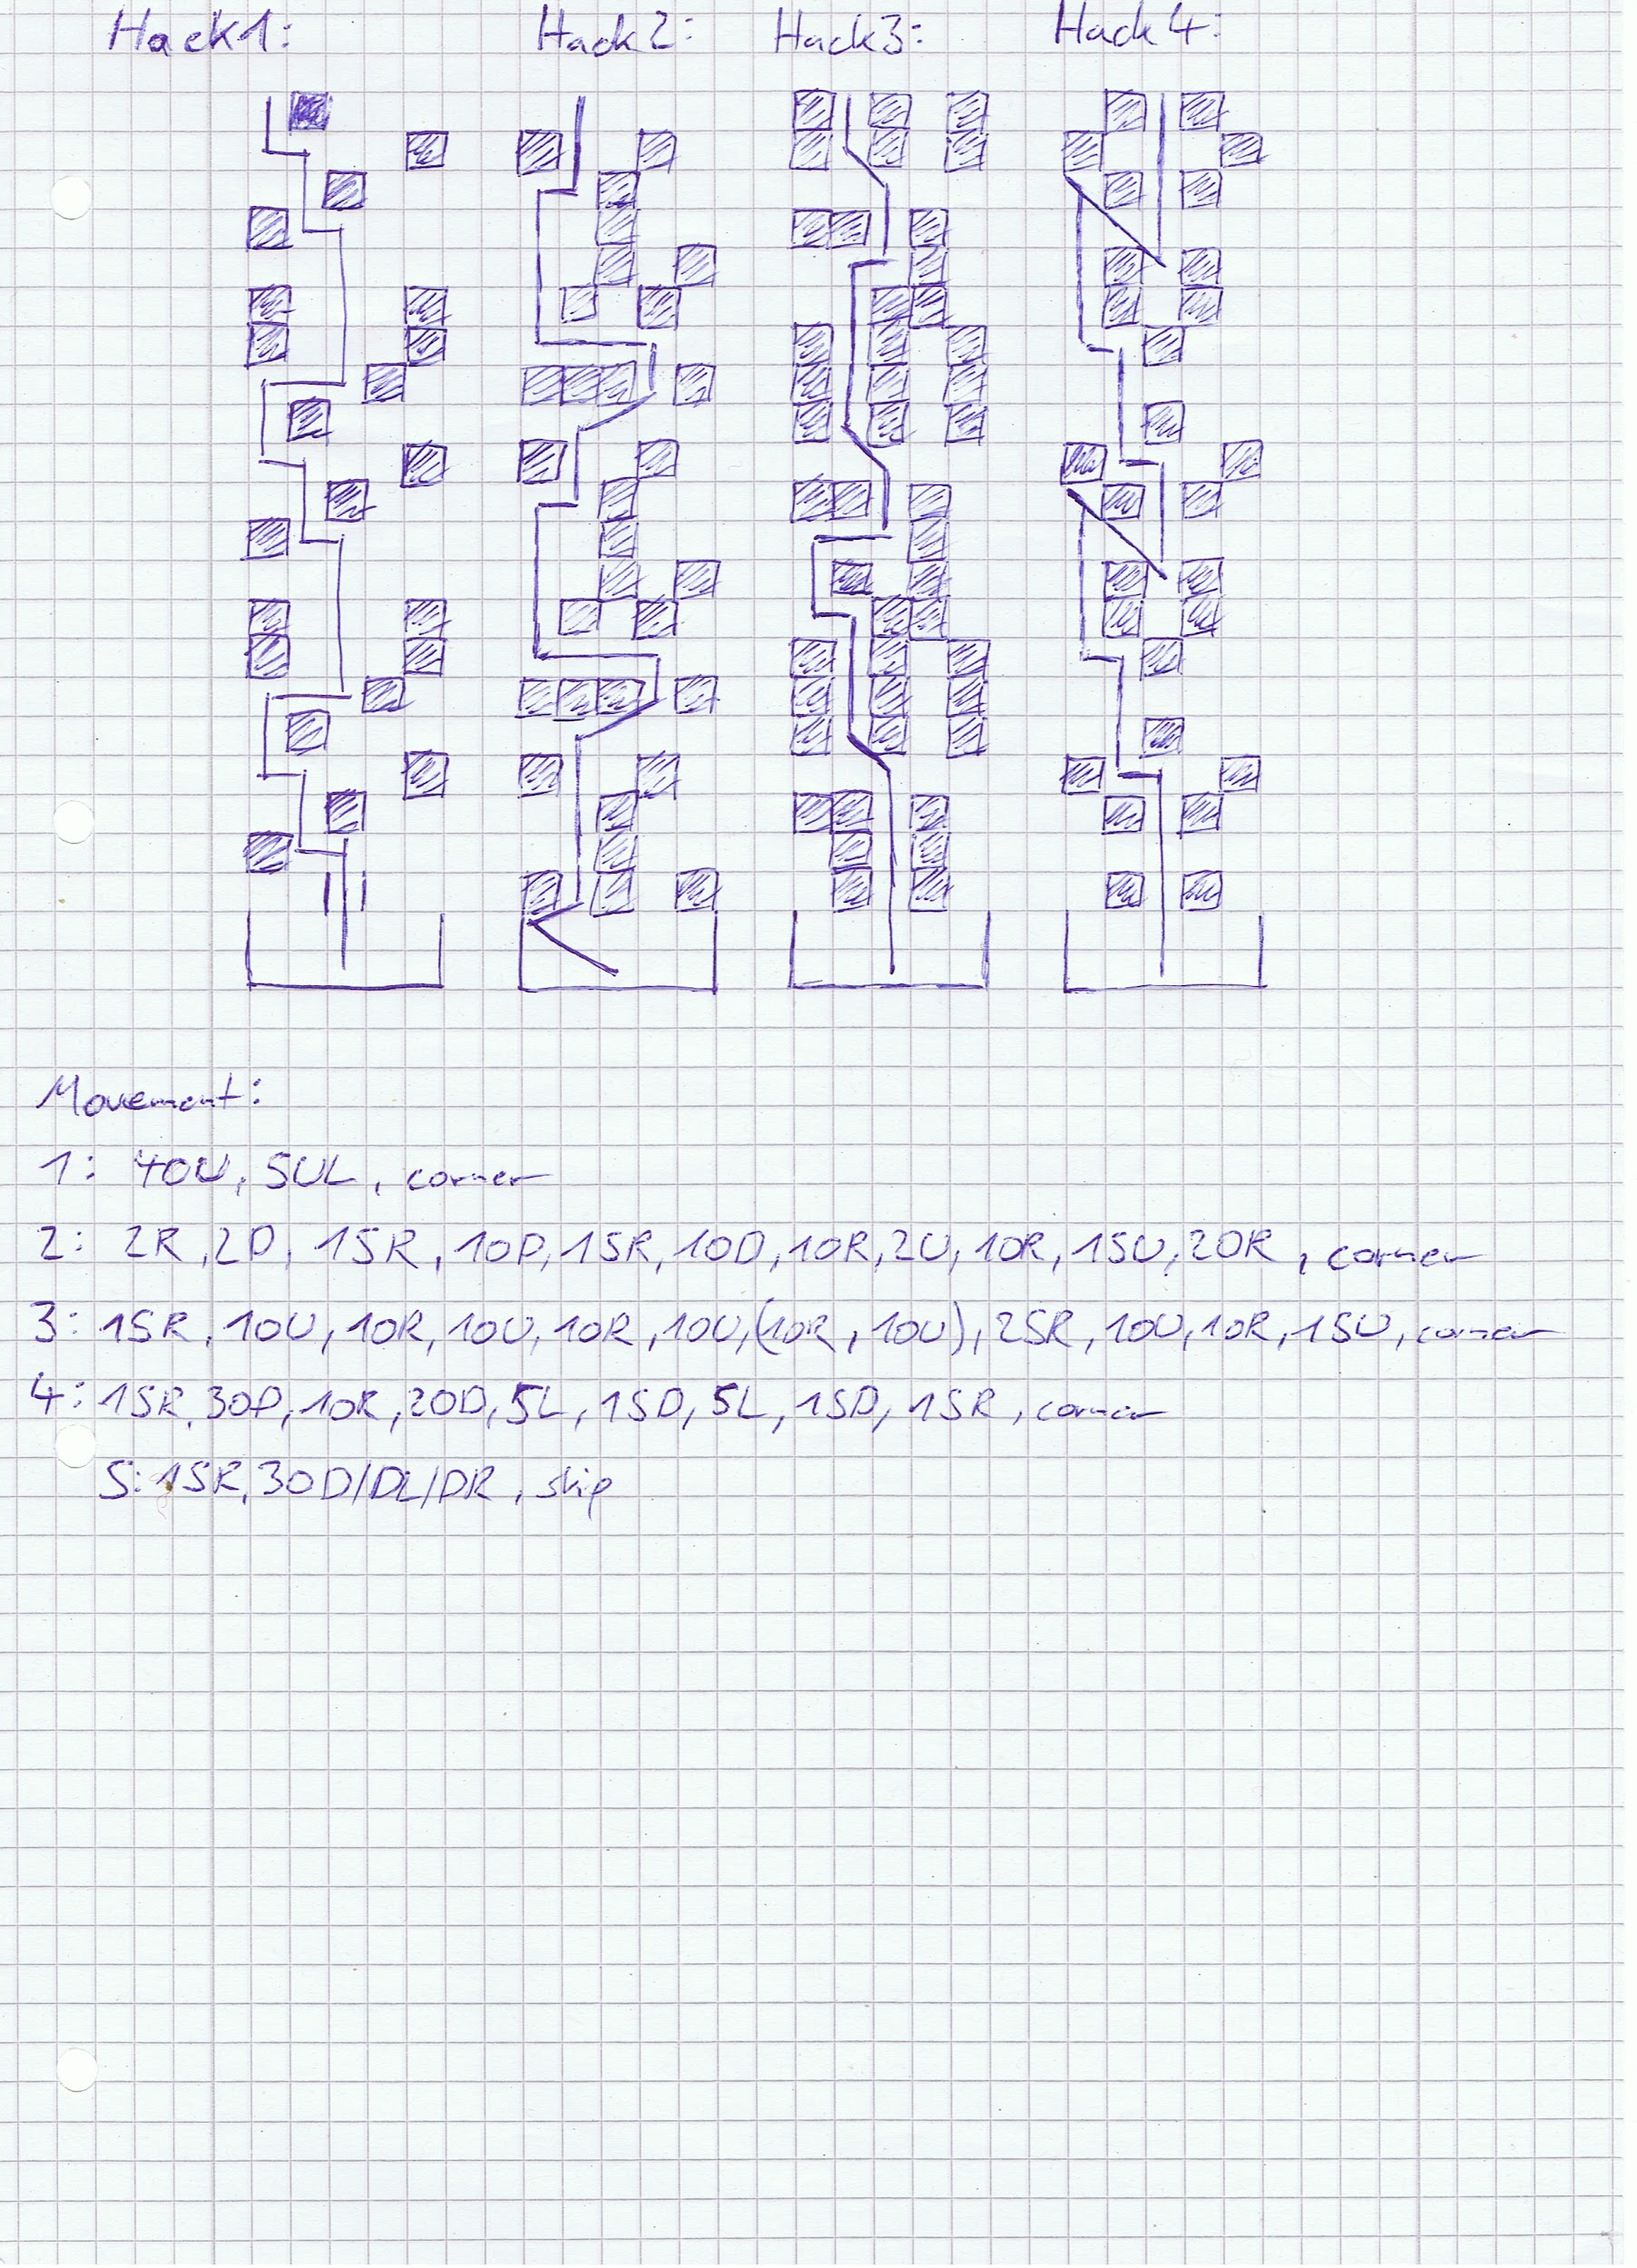

Mash LA? dash and count

40up,10upleft with wiggles

//backup:15LA up, 2LA right,4LA up, 6LA upleft,15LAupright,6LA upleft, buff kill everything(dialogue)

All the way upleft, downleft dashes (5ish)hack

Hack1.

Up4,left2,up,left,up2,right2,up4,left,up,left,up, up, right, up , left, up , left, up into kill

2LA right,2LA down, 15right,10 down, 15right,10down,10right,2up, 10right, 15up (lazer), 20right(corner), continue mashing LA till most of them are dead,

5dash/8LA up into hack,

Hack2:

Upleft, uprighttap kill, upright, up4, upright2, up1,left3,up4, right1,up2,upright2,up1,left3,up4,1right,3up,kill

15LA right, 10LA up, 10LA right, 10LA up,10LA right, 10LA up,(doorclose),10LA right, 10LA up (lazer),25LA right, 10up,10right, 15up into enemies

// backup? 10LA downright, 8LA right,8LA up,6LA right,14 LAup, buff mash LA till all dead(downtap),8LA downleft /dashes,hack

Hack3( you might get shot while hacking, just hold Y afterwards):

up4,upleft2,up3,left1,up2,right2,up2, upleft2, up4,right1,up2,upleft2,up1 into kill

15LA right,30 LA down/downrightish or 5right then 35down

10LA right(door closes),

20LA down,5LA left,20LA down,5LA left, 15LA down,15LA right(corner), buff mash LA till dead, 8LA up into hack

Hack4: 4up,1left,3up,1left,4up,swtich back to controller and kill 1 block downright ,downright,2up,2upleft,5up,swtich back to controller and kill 1 block downright , downright,3up into kill

10LA right,mash down dahes, 30down into 5downleft/downright alternate dashes, till door close into shmup

Equip autochips

Phase1: leftright RB dodges

Phase2: circle LA mashRB

Skip

Mash text into cutscene into shmup

Phase1: leftright RB dodges

Phase2: circle LA mashRB

(start LB at “hmmm, I wouldnt bet on that”)

Skip

holdRB up LA

“Displaying on HUD” hack 3times (EZhack)

4th hack(hardhack) RB move in big circles

Skip

Selfhack:

IMPORTANT: no audio here and you are on a timer, watch out!!!

3.5-4s up, 5supright into hold Y for first audio node (now we have audio cues)

10-15seconds downleft, upright mash Y for audio cues and hack nodes

//Important really hold Y for a longer time! If too short its rip run

//if you die: Ending F and have to do everything again from fileselect

“9S” skip

Podshooting, go up a bit, buff range mash taunt and hold RB

“Weakness found in enemy unit” into EZhack

Skip

“I told you to shut up” EZhack

Skip

EZhack skip

Podshooting2: same as 1

Skip

## Questing

### Bunker

Deactivate autochips

Mash start into QS (QSLoad if lost, 2LR,UR from QSLOAD)

2LR, neutral(door),10LR,UR;upleft into 2Bs room

Downright into hack

Mash with hold circles all the way till end

Mash till control, 3LR

2RR jump into talk, hold right into UR at end

upright/more up wiggles into door, RRs into elevator, jump mash circle for dialogue

6RD downtap jumps mash circle for quick elevator

(Alternative: QSLOAD into 5-6LR, UR upleft J till elevator

3LR,neutral, 8LR,UR,upleftinto elevator dialogue, lefttap, 3LA combo into UR elevator

4RR jump into walk skip x2

Shmup: activate autochips again

Phase1: leftright RB dodges

Phase2: circle LA mashRB, stay uprightish for fidgetspinner into left second one(might LB here)

Try skip with audiocue

Deactivate autochips

### Resistance Camp

R3, 7UR,3RR ,right DJ getup 3RR right ,neutral DJ getup, R3,U jump, UR, upDJ into falldmg,17-18UR,3LR,12UR,4ULR,lift J up onto barricade, lift J over barricade, 5UR,12ULR(till resistance music),12DRR(dialogue), 3 right J,RR,UR,LR, neutral DJ with second jump left, down mash circle for transporter

X for arcade tutorial, x for quicksave

//if lost backup QSLoad

Lefttap, 5UR DJ up till supply trader sounds, 6-7steps left, up mash circle for anemone

4steps down, right mash circle for supply trader, accept quest

if(dialogue): “pain” you have the materials so just circle again into finish quest,

Else: check backup after quest1

MENU: IMPORTANT EQUIP CS C before doing next line!

MENU: destroy chips, all the way down(support), count from top(material method reversed),

Destroy quantity = (count - 4) (2auto, 1count, 1sort)

1 down and destroy quantity

MENU: items: check material count

Talk to supply: sell: (materialcount - 1 + buffCount) (machine cores) x left x max quantity

Buy: max medium recoveries, all the way down, 1left(RAU+1),x,3up,x(quantitiy 4), 2up(WAU+1), x,3up,x(quantitiy 4), IMPORTANT ONE:

Hold right mash circle for chipvendor, select first option (mash x):

All the way up, x, (buy)

Buy:

All the way down, buy single last 7 items (chip storage) for 100k

MENU:skills,program,mash x for lazer

MENU: equip CS A

MENU: skills, chips, CS A(equipped), automatic, attack focus,xleftx confirm

MENU: weapon,WS1, x,x(all weapons),1down(VC),x,x(same with WS2)

(QS), Deactivate auto chip, 5-6 steps down , 5steps left start mash circle for wierd dude dialogue mash circle

RR,UR,LR(all short), up mash circle for weapon vendor, J up mash circle for accept quest dialogue

QSLOAD(backup anything you messed up earlier backups; same as A, 3PJ left weapon, 3steps down right supply, 4steps down left wierd, from supply downright mash circle for chipvendor)

### Quest1

R3, PJ, 6LR,4UR, 22LR, 5UR, DJ getup, R3, LR, UR, lift jump up PF upleft, dash PF upleft, land on grass, down into lift J getup check for barricade, URs into lockon autochips kill everything(9S combat sucks)

Search for barricade ( 7DR,7DLR,7DRR, lift setup)

UR,DRR into corner,

1. Keyboard upright into up mash E
2. !walk up slightest lefttap till bush sound, stop immediately, go left mash circle
3. 4RR, 3DR,RR,3URR, up keyboard 4RD,jump keyboard left mash E
4. (might try 19 steps left into down mash)10DLR, into backup

Backup for 4:left5RD, 4LAcombo(SS), jump up mash circle

“Thats enough” when all collected

Get to barricade

Jump over into RRs till water fall into DRR into QSLOAD resistance camp

Backup for Quest2:

DJ getup barricade, R3, DJ up dash ,7RR, 8UR, 26RR into transporter discovery, 2B on passive, CS C, find teleporter as in A, farm as in A till you get it continue to QSLOAD into resistance camp//TODO maybe check it out

## Desert2

R3, 3PJ, left mash circle for weapon trader quest, check for VC3 if not gotten yet(down x,x(vc),xleft x confirm if yes), else just close and mash, (return supply quest if backup), 5steps right, up mash circle for anemone, mash x into up select QS,

Lefttaps, 4DR,8LR into dialogue, 4UR, 22LR, 5UR DJ getup, R3, LR, UR, lift jump up PF upleft, dash PF upleft, land on grass, down into lift J getup check for barricade, UR, DLR into corner, 14UR, 16-18ULR into fall/concrete(same backup if stuck as A), 31-33ULR(music change maybe), URs with mash circle for vendor, might buy 20 of each buff here

//If lost, QSLOAD from desert

From vendor instant route:

QS, 2LR,

5UR DJ up dash, 15UR ,LR,13UR(dialogue),30-33LR, 10DR, 4-4.5LR, 2UR DJ up mash circle for jackass,

QSLOAD backup route:

R3, 4LR,6UR, 25LR, 30DR,9LR, 7leftRD,uptaps PJ, J getup DJ PJ mash circle for jackass

camera change

8UR, 4LR(stone),UR,RR,UR,7LR,8UR,10LR,3ULR at end, DJ up,

(Lots of uptaps for straight angle! )38-40UR,35RR, into runrun dude, wait for “cutscene” , URs/DJ updash into picturebook, skip

!IMPORTANT!: position after cutscene will save your last position!

URs into special tank cam change, continue around 35-40URs into QSLOAD (apartment complex)

R3, 8RR , RD, 7DR(spawn) into 4RR cutscene(upright if not or search)

Uptaps hold up into “nice weather” 4UR, 14RR, lefttap, 23-25DRs( might righttap) till cutscene

35 UR into cutscene( might need wiggles for getting stuck), 7UR into skip

6RR,4LR into fall SD dmg cancel, skip

Try to kill a few stubbies, till leader comes out, then autochip taunt buff kill everything try SD after 7 “this can not continue”,

Just kill adam

Skip

## AmusementPark2

5UR,11RR, 2DR, DJ down twice, 2DR, LR, 4-5DR, 2RR, 3UR DJ up dash, 6-7UR into cave, upright/UR/RR alternates

Upright into corner, 3DJright, 3RR, 4UR, 2DJupdash, RR, 5UR, 16-17DJupdash onto rock/enemy sounds, RR,UR,upright circle down mash circle for box,

5RR, 4UR, 3RR,3UR, DJupdashes until transmission, picturebook(last one!) QSLOAD

R3, 5RR into mash circle into x for confirm, 12RR,3UR,12RR,2UR,neutral, 30UR, 2RR, around 9UR into water, 3RD, 20RR into corner, uptaps into 6RD, 11RR, 7UR into dialogue, 2RD, 4 LA combo SD cancel!, jump right into ladder, let go,

R3, 6LR, RD, 8UR, 9-10URR into gravel, LR, downleft into ladder get up into skip

4UR,3RR,6UR, 2LR, 6URs into skip

QSLOAD(UR if needed, but before entering for dialogue skip)

Lefttap 4RD, 7UR

RD, LR DJ left(dump sounds), DJ lefttap onto upper part(small!),

Upright lift jump dash PF (have to hold stick all the way)

6LR till enemy sounds + music, DJ left hold left 3s, DJ PJ into “lets dance”,

R3, 3.5UR,LR/ULR into dialogue, up a bit into LR, neutral, RD, wait 3s into 4RR,2UR,5LR,UR,3RR(rollercoaster comes in), LR, DJ up onto rollercoast

Autochips on, kill with taunt RB lift DGs etc, picture book right before end if no VC3 yet Until skip

3RR into skip

Beauvoire:UR buff taunt DGs all the way till phase 1 over

Hack: up, kill all besides the last 3 behind the core, right up into kill last ones + core ,

Skip, wait skip

Dash around autochip aim for pillars, might do LAs with shockwave

Phase 3 as phase 1 skip

mash into skip

## Engels2

### DeathWarp

Mash dialogue, deactivate auto chips,

3UR mash circle for dialogue,

8DR into DJ down slow walk,

14DR into “hostile”, mash circle till dialogue over,

9DR, 2LR, 2DJ left,2DR,4LR with DJ, 5DR with DJ, RD, LA hold into DJ right for ladder, get up

20LR into skip

40LR into skip

7LR into music, 5UR into corner,DJ right dash 6RR into stuck behind transporter

Right hold into DJ down, righttap, up mash circle for teleporter, QS

2-3LR into down mash circle for pascal, talk twice till quest/item get

Same cam rules as in A,

6DR, 8DLR into forest sounds, 10DR into concrete, 12DRR into moat, 4URR into dialogue,

DR,LR, left down circle mash for box, R3, push it all the way,

6LR, 18-20DR, 25LR, 8DR,2LR,15DR,11LR, 20DR into waterfall, 19LR into 20DR(music stops, resistance)

RD, 5LR, DLR, left 3 RD SD cancel, 5DR, RR mash circle for smith (check for vc3),

NewRoute: lefttap, 5steps down , righttaps; if not go OldRoute

OldRoute: J righttap, downtaps into DJ PJ, downtap(step)

right mash circle for anemone, mash dialogue into cam change

4.5-5!UR,7-8RR into RR/DRR wiggles until grass, equip CS C, (2B on passive; not really needed), right dash into deathwarp

### Engels

(!Important: Before switching back to set A) MENU: destroy chips, COUNT categories: if 8 then support 1up, if 7 then last one

all the way down,1up (new hacking chips)(support), count from top(material method reversed),

Destroy quantity = (count - 4) (2auto, 1count, 1sort)

1 down and destroy quantity

Equip CS A, automatic, attack focus

RD, DJ right into ladder, getup, 2LR, J up dash, J upright dash into house, downtap left mash circle for pascal, leftsteps into J DR, 2.25RR into down/downleft for ladder(might need to press x into circle for ladders),

2-3LR

Same cam rules as in A,

6DR, 8DLR into forest sounds, 10DR into concrete, 12DRR into moat, 4URR,

DR,LR, left down circle mash for box, R3,

20LR,15UR into corner, 7LR, J getup R3 (backup QSLOAD into RR UR LR setup)

3.5LR,19UR, 3LR, 25UR, 1.5RR, 4UR into lift J getup barricade, ULR on barricade, DJ up dash over it, 6-7RR, 28UR, 15RR,UR,5RR,2UR,2RR, 12RD,5+URs into fall,2URs into corner, downlefttap for ladder, 20up, let go RD,4RD into fight,

Engels1: wait for fight sound, autochips, taunt, buff, RBLB spam, if melee try DGs until dead

Deactivate chips, 3-4DRRs into fall,2DLRs into corner, uprighttap ladder, 20up, circle RD, 6RD,R3, 2RR right a bit, DJ PF, 6.25-6.5RR into DRs mash circle for flight unit

Engels2: up buff LB when fight starts, around 25LA into LB for kill

Skip

## Negotiations

17-18UR,5LR,9UR, DJ up,13-16UR (fall skype glitch, needs to be fast) into DJ URs/ULRs till long fall

LRs till light tutorial, 4LR afterwards, 10UR,LR, 6DJ LR/ULR, 6DR wiggles till water, 2LR;

22ULR into fight(dialogue after water in entrance)

Skip

Wait for alarm into picture book

(MENU:5right(1from right),all the way down, 1upx,x,left,x confirm, skip with cirlce, close menu

Skip

## A2

20-21UR,3RR,3UR,7LR, 15UR(footsteps),4RR, 10UR, left mash circle for jackass, mash dialogue, activate transporter with up mash circle, QS, teleport to bunker

Skip

mash , 6RD into 2LA SD cancel, up J uptap into circle for quick elevator

LRs out of both doors, 2LR UR into transporter (if lost QSLOAD)

QS transport to pascals village(3up! Changed values important!)

RD, DJ right for ladder, get up , 2LR, J up dash, J upright dash into house, downtap, left mash circle for pascal, select 1up from bottom, mash trough dialogue

Leftsteps into J down dash, 2.25-2.5RR into down/downleft for ladder, uptap circle for getdown

If no VC3check in resistance at engels: 3LR, ULR righttaps mash circle for smith, check for VC3 again if needed

If not getdown from ladder into full LA combo into upleft/left mash circle for transporter,

QS transport into city ruins near tower (4down)

R3,4LR, 5ULR into upleft wiggles into corner, DJ up into PJ hold up a bit ,20-23LR into facility , 10DR, 8LRs into slowwalk, go neutral into 3RD, try dialogue cancel, kill the machines with buff taunt

Skipx2

### Forest

5UR into RD DJ up 5UR, 30-40RR into cam change, hold stick all the time, then after dialogue start wiggle with DJ dash right upright ish into the cutscene

Skip

12UR into LR kill enemies at transporter

Activate it with UR LR DLR down into downright circle mash  
QSLOAD

QSLOAD: 3RR;22UR, 4LR, 4UR,LR,5UR DJ dash up, 2RR; 11UR into river,RRs into “how are we supposed to reach that castle” into 8URR, DJ upright dashes till drownwarp

UR, DJ dash hold pod for 4seconds, PF dash, 8UR, 10RR ,5DJ right dashes, 3UR DJ dashes into skip (cam change,position)

23UR into cutscene start, R3 mash when over, DJ up dash, 2UR,2RR, 16UR (might QSLOAD from here if lost again, definitely save before castle tho)

DJ updash, 10UR into corner, 4LR, DJ up dashes into castle

QSLOAD: 3UR, 2RR into fall, 5UR, 3.5RR DJ right into castle

### Forest Castle

Music start, 4RR into DJ right enemy, 4RR DJ right dash over enemies, neutral, DJ with second jump right dash over gap, 10RR, DJ rightt till landing, RR DJ right over enemy, RB into shoot floor, find window(shooting stops for a tiny bit), downtaps, LR,DR delayed lift jump hold up into grab ledge getup, RR,DR,DLR,DJ right into ladder, getup, LR,DR,DLR, DJ right into ladder, getup, 3LR neutral, 3LR neutral, 3LR into cutscene

Skip

4LA combo into delayed lift jump right into getup, 3UR/URR neutral, 7-8UR, QS, DJ left dash,

LRs into A2 fight

Mash taunt into buffs and DGs etc.

Skip

## Grun

2LR into DJ left dash out of the window into falldmg, wait the dialogue and skip

Wait for next dialogue into picture book, QSLOAD

RD up mash circle for transporter,

Transport to pascals village (5up)

RD, DJ right getup, 2LR into J up dash, J upright dash into house, downtaps left mash circle into pascal, choose first option

Lefttaps, J down dash, 2.25-2.5RR into down/downleft for ladder, get down

4LA combo into ULR, left into downleft mash circle for transporter

Transport to resistance camp(1down)

R3, wait for second dialogue, picture book, 3PJ, left for weaponsmith if no vc3 yet or 5steps right into up for anemone

Mash dialogue

3DR, LR into down/downleft mash circle with RB for transporter

QS transport to flooded city coast(1up)

2ULR into cutscene, skip

R3, 7UR, 5ULR, 19UR through camchange into DJ right dash 7RR, DJ, ULR, DJ right 3ULR, DJ right, 3ULR, triple PF to the right into fight

If drown warps: first: 5-6RR into DJ right continue;

second : 5RR into ULR continue;

Kill everything into drownwarp upright, picture book into skip

Wait for landing, up mash circle for flight machines

Shmup: as always (as A)

“2.5clicks” skip

Goliath: up buff into LB, 30LA, LB LA till dead

Skip (x2) //not sure if second skip works in B

Skip after “sending coordinates now”

Kill core1 as A

Skip after “lazer strike”

Wait till landing for mortar, 3UR into EZhack,

Picturebook

Hack again EZhack,

Skip x2

Continue shmup as always till 9S leaves

Skip

Shmup as always

Skip

Wait for missile, skip x2

### Hack (count slow pseudo beats):

3R,4U,2R,2D,1R, up mash triangle

6R,5U,2R,2U, 1.5R, down mash triangle

3D,3L,8D,2R, downleft mash triangle

1D,5L,8U,5L,2U,2L, right mash triangle

15U,3R,3U,1.5R, down mash triangle

Wait till mash into skip x3

## Factory

### SelfHack:

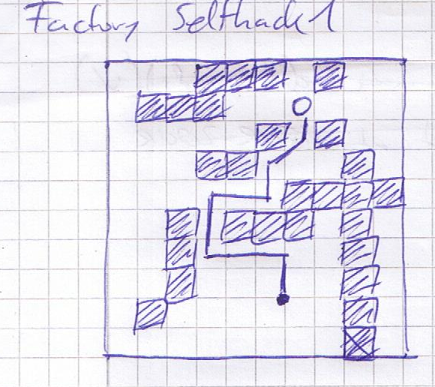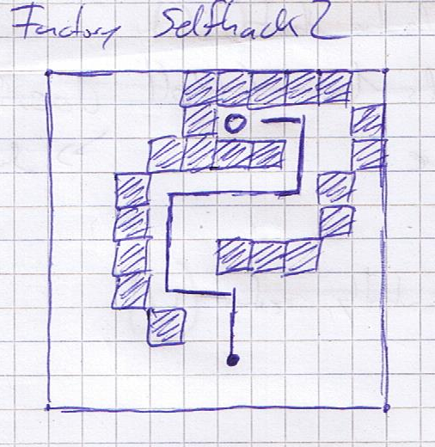

Triangle

5L,ULtap into triangle, right mash triangle for total 6 cores

10UL,triangle, right triangles total 3 cores

7UR,10UL, after dialogue “virus”, 1R, down mash triangle

Wait for dialogue, 15U into dialogue

6UL into mash triangle till you get it

Up,left RB left till wall, upRBuptillwall, rightRBrighttillwall,upRBuptillwall, autochip right RB into kill

Wait for pop up x twice

12UL into mash triangle

RB up, RB left, RB up,Rb right, RB up, RB left

Wait for pop up, x twice, wait for cutscene

6UR into dialogue, neutral, find the core, kill everything with autochips

Pop up, x twice, wait for dialogue into skip

2LR, 11-12RR,UR,upright into door opening, righttap 3LA combo dash up into terminal

From QSLOAD: 15LR,UR,upleft into door opening, lefttap 3LA combo dash up into terminal

//door might not open instantly in both cases, wait a bit

3RR mash circle after dialogue

Mash till hack:

### TerminalHack: (real beats this time)

16UL,1UR,1U,5UL, DR mash triangle for core

Wait till dialogue

R3 up into dialogue neutral R3 again, up into upright

Crusher death:R3,20steps up,upright till door closes, righttaps, 13 RD a tiny bit after crushers land

Lockon HA after 6! Seconds waiting, remote control him (last option)

Hold right a bit, 7RD, lockon hack remote, down into trigger into hack

//backup if he is not there ; 15 RD, up into “stop, GODS” 4UR jumps with a bit up into door opening, right into door,”9S talk look what”, DR jump Lockon hack remote control, //TODO check

Upright into right, 9 RD, hold down till steps,

15steps left, jump delayed lefthold twice, hold left into lockon hack (hardhack, move around in circles), (he just explodes), full jump left, hold right, 11RD, straight up into door till dialogue end, 13RD, upright wiggle into right into down, hack a after getting through door, keep holding x for flight, wait for crush then just hold left, after crushers lockon into hack fly dude

BACKUP FLY DUDE CRUSHER DEATH: R3, buffer DL until crusher, then down into hack

X rb left for 90 shots, then stop shooting just left, at music fadeout x again and x when next enemy dialogue starts, after enemies just left till door opens, then up into hack

Skip

Mash

### FactoryHack:

UR,U a bit into UR till fight starts, kill everything

UL,DL, 4beats right, up mash triangle

UR,U;UR, kill everything with big circles

UL,DL, 4beats right, up mash triangle

UR,U;UR, kill everything with big circles

UL,DL, 4beats right, up mash triangle

UR,U;UR, kill everything with BIG circles

Skip x2

Mash into QSLOAD

## Eve2

2RR DJ into dialogue mash

Skip x3

Left mash dialogue QS

2LR into neutral, 13LR, UR, upleft into door open, lefttap, 3LA combo into UR into elevator

4RR DJ into skip

Shmup as always

After wind sounds mid buff LB

Skip

Core 1: (taunted enemies start do do half HP one hit without buffs, watch out!)

Taunt buff into DGs etc

Skip

QSLOAD into resistance camp

RD, up mash circle for transporter

QS, transport to city ruins near tower (3down)

R3, QS, (circle 2B to passive) //passive not really needed, enemies too strong

15URs into water, DJ left ULRS into enemies

Kill everything with taunt buff DGs etc.

Kill core2 somehow (this fight sucks in emergency already here equip CS C for lockon)

After kill SD, MENU: switch to CS C, search for enemies with lockon and kill yourself

Continue

RR,UR,ULR into neutral jump getup R3,

MENU: equip CS A

3.5LR, 18UR, 2LR, 13-14UR into skip

Eve: Phase 1: buff taunt DG etc., if you get platforms try getting away and get a lockon somehow, then lazer and hack him till platforms go away

Hack once “on it”

EveHack:

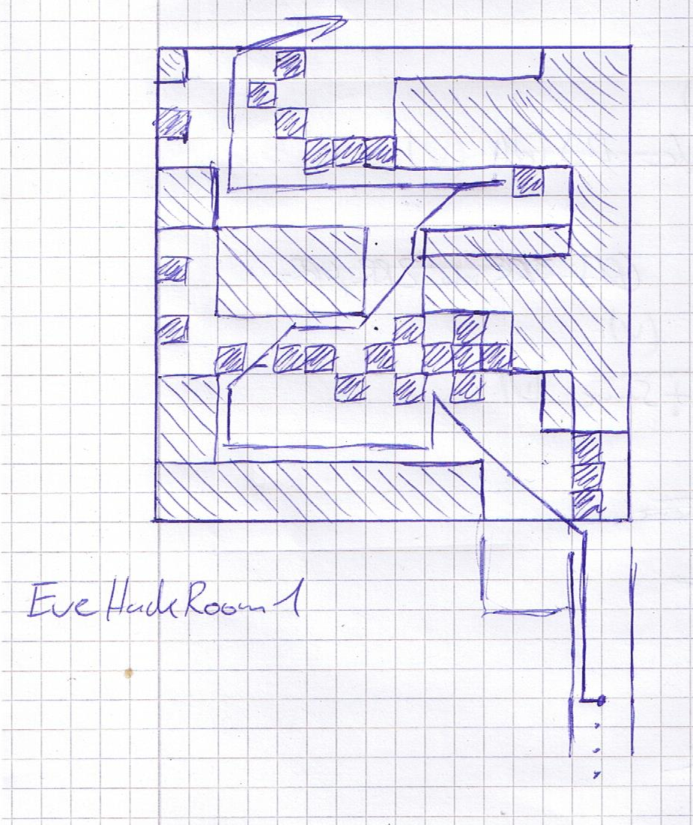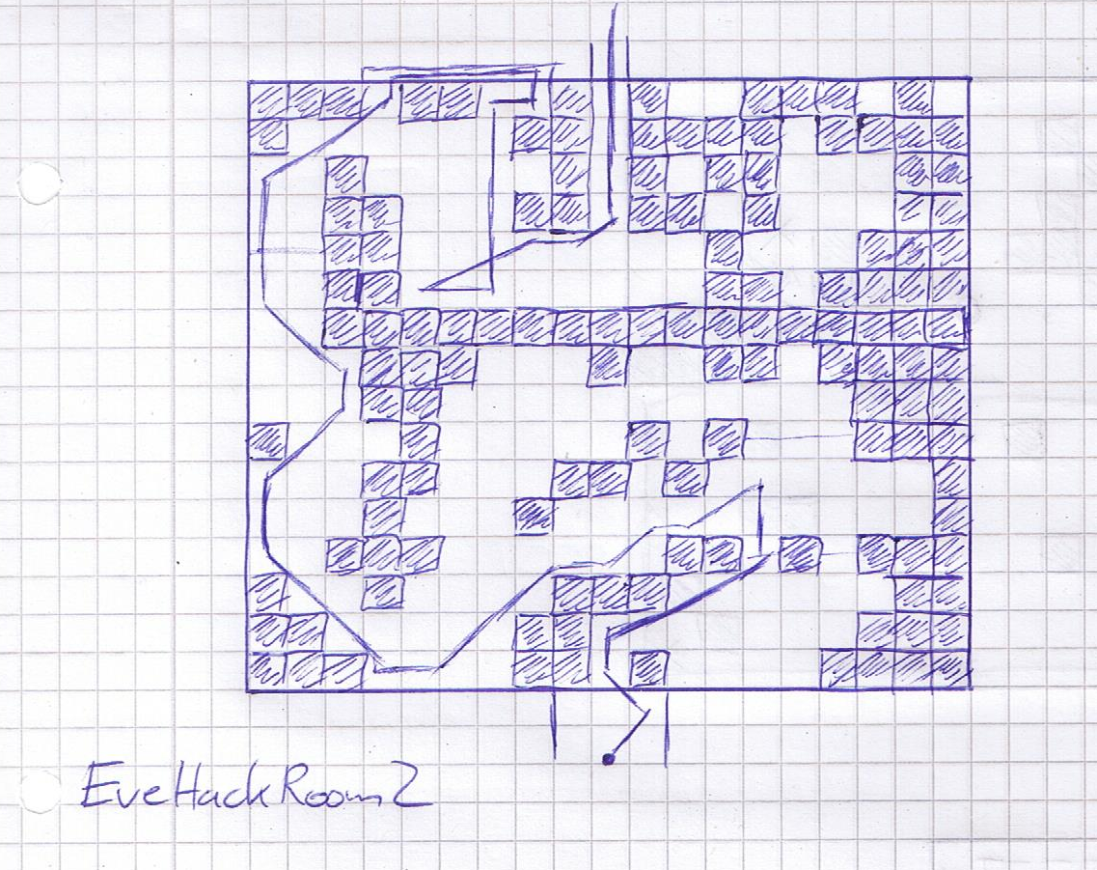

(keyboard) up shoot till 2 kills (“brother, oh brother”), 15UR all the way into 20U, ULR shoot into kill,

hold ULR for a bit then U shoot till wall, UL shoot till wall, DL a bit kill 1 block, U shoot into wall, buffered URshoot into U shoot, R shoot,UL,UR till dialogue “my brother”,

UL wall, UR wall, U 1block stop shooting U, DL wall, into D, UL a bit, UR,UL 1block, UR wall,D,L,D wall, L wall, buffered UR wall, U 6block into skip x2

Eve P3:

(Taunt buff RB LB into hack) x3 then finish off with lifts etc. if shockwaves

P4: buff taunt and heal every 2 hits, uptaps up with RB all the way, make sure 2B is on long range

Skip

Wait for 9S

Skip

Credits skip with circle hold

Skip

9RR, UR, slowly upright into 9S room, all the way right,

downtap into mash, 2LR out of the room neutral,

8LR, UR, slowly upleft into 2Bs room into up skip with circle

IMPORTANT: left x for save

# Ending [C]

## 9S City Hacking

### Bunker

X,x,x left x for continue,x for start game

Skip

Uptap Circle for vendor

Count machine cores, discard e drug and speed

VENDOR:Sell machine cores (count -1 + buffs)

Buy: max medium recoveries(1 down)

buffs(8from top,7from medium) 61 of each (5 right) MAX THEM

Cure manipulation(5from top), 51

Buy all you need then max out large recoveries

2LR,neutral,3LR, UR, upleft into door open, lefttaps 1LA UR into elevator

3RR DJ into flight machine skip

Wait unskippable cutscene

### City Hacking

3 times picturebook into QSLOAD

From QSLOAD:

2LR, 20UR DJ dash up, 6UR,5LR,3RR with downtap (item), up DJ PF around corner up into right,, ULR, downright DJ into ladder or RD full LA right DJ,getup 4UR,3LR,2RR into ladder,getup, EZhack

4UR DJ up, 10-15 dashes into QSLOAD

Transport city ruins near tower, (3down)

R3

Buffered right till first bush stop instantly(keyboard cancel)

Buffered up into around 35steps into ladder

Get up ,cam left a bit into HardHack, QS

Downleft taps into ladder

Wait a bit into getup

Buffer upright into R3, DJ up into fall

5LR,6UR into try neutral shot for non cam jebait

Else shoot up with right analog stick, down again into hack as soon as you hear steps

Backup: QSLOAD RR,UR,ULR neutral J getup R3,

15-16LR into 7-9UR shoot up with right analog stick, down again into EZhack as soon as you hear steps

Buffered up Picture book, 10DLR into QSLOAD

Up mash cricle for transporter

Transport City Ruins Center: (2down)

QS,R3, 10RR, neutral shoot into enemy drop hack (doesnt work sometimes? QSLOAD)

10DLR, left J getup, down J getup,R3

7UR into drop, 4LR(DR) neutral shoot into enemy drop hack

8DRR, right J getup, down J getup,R3,

10UR(drop at 7), 7DLR,13UR, 7URR, DR,RR,UR DJ up (close the the root or on it), 2LR lift J uptap into getup or concrete floor, 2.5-3LR, 3UR up J, neutral J getup, 2UR rollout, J triple PF with first up second two upright (onto bridge) into URR cutscene (can skip but tiny window)

## City War

Skip at first skype

Shmup as always, might LB fidget spinner in phase 1, continue into skip

(2Bagain)

Keyboard buffer downleft R3, double lift plunge up, 15-17URs into the first fight and QS there

Kill everything until dialogue (if you miss an enemy QSLOAD into RRs)

Picturebook into QSLOAD

R3, 3LR DJ left plunge, 2LR DJ left plunge into fight (big machine can 1hit, so LOAD after dying for chips) //might also use edrung and speed up here just to get rid of it

After kill all the way left, 9-10LRs DJs till fall into pit (watch out, if too far Ending O!!!)(also dont hit the ladder or save upright!)

Might podpad for dialogue skip

DRs into RRs, for transporter

QS, transport to resistance camp (1down)

PJ, 5LR (dialogue),3UR, 10LR into fight, kill everything

Buffered keyboard up R3, double picturebook, “we need to hurry” Backup: get back QSLOAD

10DLR all the way, 10DR all the way ( corner with bush at barricade), 3LR, UR , 3LR, neutral double lift SD cancel getup, R3, 4UR drop, 22LR(might QS earlier starting with like 16-17LR)

10DR into fight/dialogue (backup QSLOAD and go RRs into fight)

Kill everything into skip

UR, DJ up dash fall SD mash, QS, buff instantly into taunt kill everything, spam cure manips once attack or dodge is broken, either hack everything or try to cue manip into one DG throw

skip

Buffer upright, EZHack into mash start for QS!!! (next cam movement is random need to find save)

skip

10RR into dialogue skip lefttaps hack for 2Bhack

2BHack:

Up3, buffered upright2,up6, after 6th instant buffered left4 with upleft taps, up6 into instant buffered right4, up16 into auto chips for kill

(very tight timewindow)

10LRs wait for dialogue into QS “marking on map” (find the save somehow, cam is a bit random, mostly its left /downleft)

Try 20UR into QSLOAD center (if still near factory go LRs into QSLOAD)

R3, 3LR DJ left plunge, 2LR DJ left plunge into fight,, kill it into instant picturebook,

Picturebook at “its possible”, after I have an idea”

RNG find 9S or wait till cutscene starts with auto chips

## 2B Death

Skip x2

QS

3RR UR upright into door (1RR from QSLOAD)

RRs into “woah” instant SD into wait 1s into URs DJ mash circle for dialogue

Skip

Important! Dont touch camera here at all (might mash R3 buffer during intro)

Kill everything

All the way up, 5UR into 6UL, buffer up keyboard ,3RD,2LA single punch SD cancel, jump right keyboard, jump righttap circle for elevator, 3UR into corridor “glory to mankind”

RRs kill waves until hanger 2B dialogue,

MENU: WS1: all weapons, one down VC (barefist will be HA)

RR,URR,upleft, lefttaps LA, wait for door open into UR

3RR DJ into skip, mash dialogue, skip after “order”

Shmup, just dodge, after dodge breaks do big circles

DEACTIVATE AUTO CHIPS BEFORE skip

Skip

Virus Skip:

(everything needs to be very quick and done first try, else reset with LOAD)

As soon as moveable (sword disappears), QS, 2RR, triple PF with first right, then down then dash up and PF neutral into down again, void out (we try to jebait as much enemies as possible)

As soon as you land: 3DR, LR, jump left, LR, neutral jump get up R3, upleft lighthold, full (4)LA combo, lift switch weapon set, HA, jump PF, dash downleft with slight downtap PF into building

DLR,4DR,2LR,4DR,3.5LR into jump void out,

15DR,RR, 20DR, RR,6DRR, 23DR (fall at around 7-8 try perfect dash), 7LR, 1.5DR into double lift dash down PF, 4DR to enemies (virus probably starts around here if perfect), continue holding down till you can dash again, then 2LR (might do them earlier at the enemies if still time), 10DR into corner, 5-6LRs into virus 70%,

downleft on keyboard for 10-15 seconds into down righttaps till bridge and “90%” explosion, just hold down on bridge, till “anyways” 2B, then left a bit into downleft until fight and skip

A2: Autochip into mash LA skip

9S:

15UR, 6LR,QS, 5UR, ULRs into skip

Backup: QSLOAD into 4LR, 4ULR, wiggles, into up DJ PJ up, LRs into skip (bridge movement)

## Meat Box

Skip, ! most important input! Mash circle into X for 9S, mash

Skip, mash text

//backup(QSLOAD)

4steps down, 11steps right into run, 10RR with uptaps down keyboard, straight buffered right (15steps) into forced walk, neutral skip

Backup: QSLOAD, R3, PJ, 7LR, keyboard up, straight buffered left(15steps) into forced walk, neutral skip

R3, 15UR,10RR,around 9UR into fall, 2UR into subunit sound,UR, righttaps hack till get

17RR into J right into pit/fall, 3UR, 3LR, try dialogue skip mash circle hold left as fast as possible, hold slowmo for audio cue to stop, if you dont get it, 2picturebooks

Transport: forest castle front (4up)

QS , R3, UR, DJ left into cutscene

12LR,20UR into skip

Slowwalk up into little fall,5UR into lift J up PF dash

Backup if drown warp miss: buffer downright keyboard, R3, 4UR, J up, 8UR lift J up PF dash

Up

Continue DJ ups until dialogue end mash circle for elevator (might need to go upleft)

RR into elevator

(QSLOAD backup after initial discovery cutscene: UR, DJ left, 19LR; 20 UR into cutscene)

//in the whole meatbox, dont forget to buff etc since you can die very easily

2LR, 5UR,10RR,5DR,5DLR into fight, kill everything

Elevator sound into URs into elevator,

DRs into kill biped and 2 flyaxe with RB LB and grounded! No aerial fighting here you can fall down

After elevator sound wait a bit into URs, 3LRs,10URR, URs wiggles into elevator

DRs into kill everything, after elevator sound wait a it into URs enter elevator

2DR into instant neutral elevator sound camera change, wait a bit,

3UR,4RR,6UR, 4UR, 4UR wiggles(upright) into elevator

5DR into kill everything ( moving floor + flyers, lots of PJ)

Elevator sound into URs

3DRs into sound,”speculation” go instantly neutral for cam change

Kill 4 machines, “help me” focus cam into UR wait a bit if close enough(sound cue)

Skip

Deactivate auto chips into 2RD, slow uptaps mash circle for cutscene

Skip

## Meatspin

Mash circle for “Select 9S”, x, mash text

16UR, DJ up 5UR,9RR, 5UR (neutral reup),4LR, 7UR, 30LR QSLOAD

Up transport: city ruins center (2down)

Make safety saves here on all 3 slots

QS,R3, 3LR DJ left dash fall, 3LR DJ left dash fall, 3LR up taps mash circle till activated, “granted” into hack

Subunit1Hack: upright buffered, up buffered into autochips

//watch out for ladder hits down in the pit!

UR, 15LR J left into pit, DRs into RRs into mash circle for transporter

Transport city ruins: center (2down)

QS,R3, 3LR DJ left dash fall, 3LR DJ left dash fall, 8LR ,4UR up taps mash circle till activated, “granted” into hack

Subunit2Hack: autochips up a bit into wait for 3 kills then all the way up

5LR,2DR,3LR into J left pitfall, DRs into RRs into transporter

Transport city ruins: center (2down)

QS,R3, 3LR DJ left dash fall, 3LR DJ left dash fall, 7LR (tiny bit right of last one) ,DR down taps mash circle till activated, “granted” into hack (if not far enough you can get stuck right of it and walk left then 4steps up ,2 left circle)

Subunit3Hack: up till wall, upleft3, up into autochips

(subunits are really easy to miss, just try again if no hit or try to hear them if close)

Uptaps until tower unlocks, then 2URs into hacking (either SD cancel hacks or just hold)

TowerHack: upright3,up till wall, upleft2, up2, upleft2, autochip up kill everything, upright into up kill everything, door unlocks, upright into upleft till enemy spawns, then wait till skip

## Tower

Mash circle for dont read,x, mash text

Wait for door opening, 11-12UR,QS, 15RR, DJ right into drownwarp

respawn, J up PF J upleft PF, 5ULR,DR, 7LR, downleft J PF J dash PF till solid ground,

after you hit solid ground, left J dash till drownwarp

Respawn, UR DJ up, 2UR, left DJ dash (might also upleftish),4UR, 4LR,4UR(or try upleftish), into little pit,DJ left dash mash circle for door, R3 as its opening

3UR into skip

2BFight: (first time do DR into SAVE) 5DR buff mash into slowmo SD (not too early), after fight(dialogue) SAVE

RNG find crawling 2B in the entrance section, should be downright into left up scanning or QSLOAD for another try

Skip with circle hold

A2:

Deactivate auto chips

MENU: WS1, VC on HA (all weapons,1down)

3URs, 5LR, just left a bit, LR,UR, DJ up plunge into neutral (cam change)

RR,3UR, LR, up mash circle for door, downtap LR into elevator

QSLOAD when elevator halts

4UR, 6RR into DJ right drownwarp (upright at first RR)

respawn, J up PF J upleft PF,2ULR,DR, 3LR, downleft J PF J dash PF till solid ground,

after you hit solid ground, left J dash till drownwarp

Respawn, UR DJ up, UR, buffered upleft on keyboard into keyboard DJ and just hold until after dialogue of fall into DJ for pit, you will be stuck left of the door, UR LR DJ left into voidout,

Respawn, 2UR,ULR, buffered upleft J, UR (15up key), hold left for 5steps, DJ, 5steps DJ, 15steps DJ, 1step DJ just continue till music gone into circle for door

Skip

2ULR after dialogue, QS, into upright mash circle for first book, wait for dialogue, circle again for book

BookHack1:

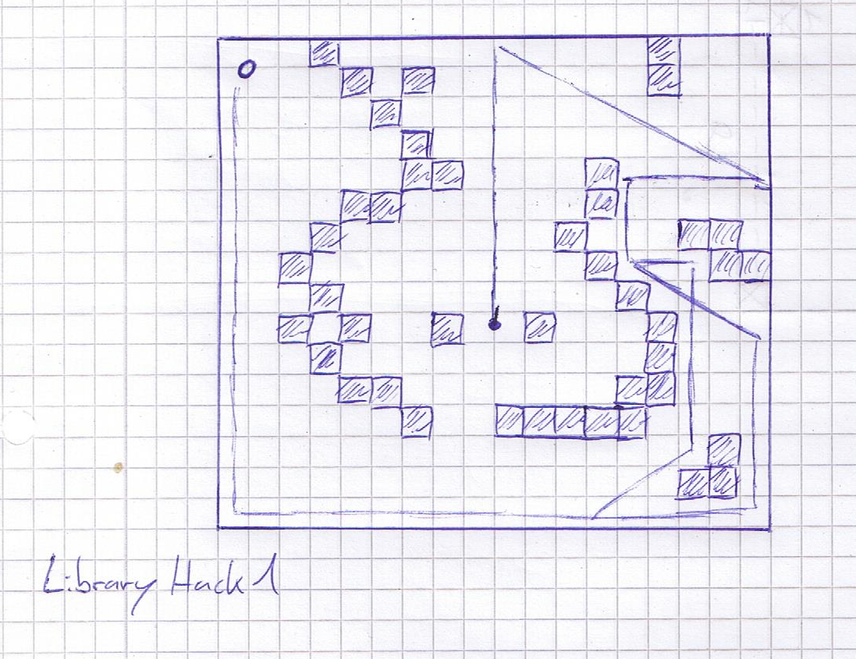

all buffered all the way, up, downright all the way, left, down, downright, left down, downleft, up into autochip, mash for item

Triplelift up dash, LR, downleft for next book

BookHack2:

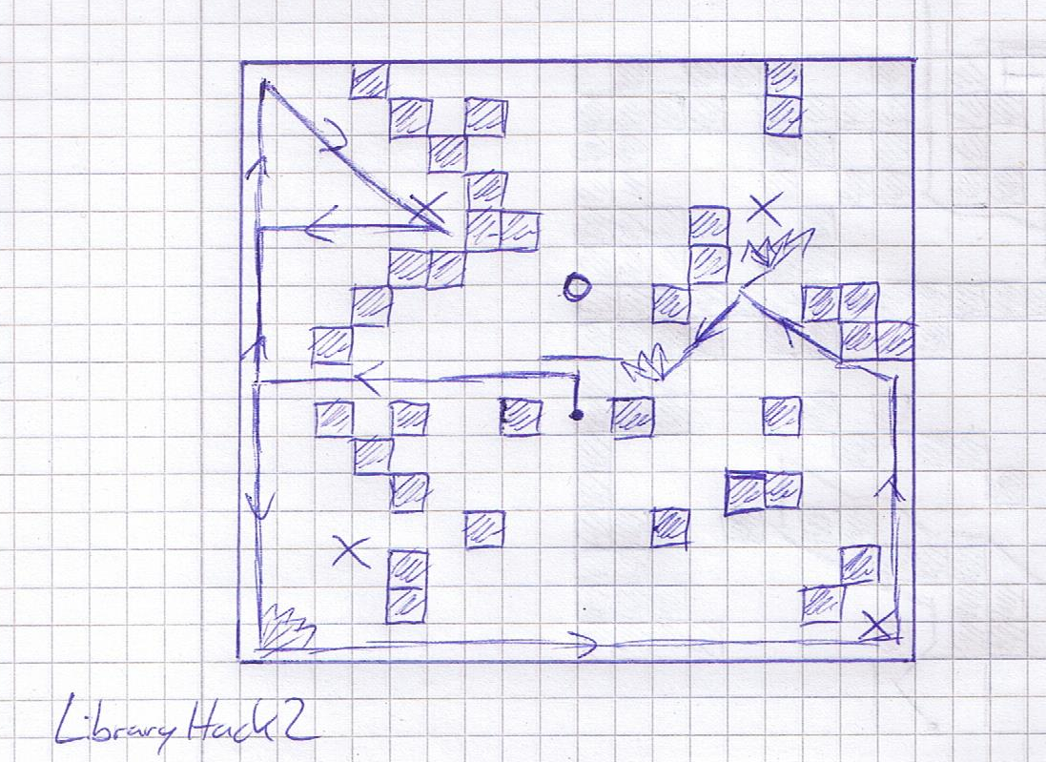

upright (instantly buffered from start), down lefttaps into kill, downleft (no shoot), up, right, down (check around with controller for kill if not sure), left, kill with controller upright wiggles everything, up, downright wiggles into kill everything till kill (barrier disappears), down, right,up,left autochip kill

Mash for item

DR,2RR,upright into hack

BookHack3:

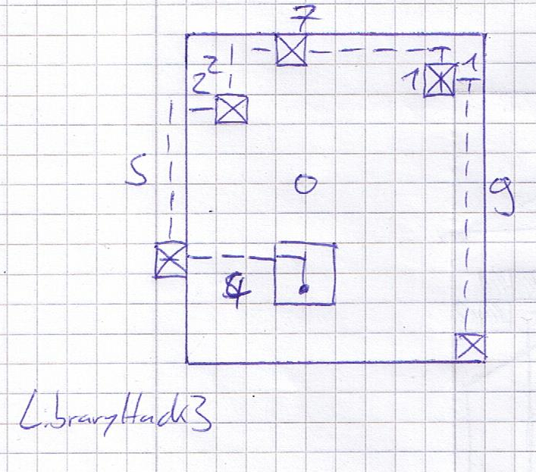

up,4left,4up,4right,kill everything with stick upish, uptap, 3right,9down into last kill, if not improvise

Mash for item

DJ left into neutral cam change, uptaps into hold up into skip

Skip

9S:

Keyboard hold up , “Urgh” into picturebook

Hack with autochips and just small circles around the ball

15UR with wiggles into 3URR, into 7DRR till red girls spawn

Picture book on “yorha unit 9s”

Kill 3 waves of enemies, mash for item

Skip

13-15UR into flyingMachine fight, kill everything

Skip

Up mash circle for flying machine

skip

Koshi: kill him, QSLOAD,

5UR,2LR,2DLR, hold left, buffered right 5steps, up 4-5steps, lefttaps mash circle for elevatorhack

ElevatorHack: 2UR, URR,2ULR, ULR/URR alternates into red girls

“Who are you” (right at the beginning) picturebook

Fight girls (buff,taunt mostly RB and LA HA alternates for distance (if shockwave))

“Proposal” picturebook

Run around(no kills) until “the androids and the humans” into picturebook

Run around(no kills) until “we are one” into picturebook

Wait till skip

Up Buff SD into kill everything

## Ko/Roshi

UR into normal fight as always (no buff)

Wait for “someone … this hole” into picturebook

Skip

Shmup: when HP bar comes in, stay mid (LR from right vice versa), buff LB and mash LA into reLB after a while

A2: kill everything

Skip

9S: buff LB LAs into LB (after like 15LA)

A2: kill everything

9S: buff LB LAs into LB (after like 15LA)

A2: buff kill tentacles with RBLB lift HAs plunge etc. then kill Koshi

DONT SKIP

2D9S fight: buff up LBRB into up LAs (reLB after around 20LA)

DONT SKIP

A2: kill Koshi (try to actually lock on to him and not tentacles)

9S: shmups

Repeat till dead (grind sounds)

DONT SKIP

FinalFight Koroshi: buff taunt (volt salve if you have) into just DGs all the way

//character switch at distortion sound

Skip

## Finale (C/D/E)

Mash text

Skip

Mash circle into x for A2 up x confirm

Kill 9S

Skip

//all jumps sprinted

HackWorld: UR, upleft a bit, DJ up PF upleft,ULR, 3URR,ULR, URR, DJ full dash up,URR, DJ hold upright, ULR, DJ up, ULR, 2URR, DJ PF upright, LR, ULR,2URR, 3ULR, 2URR, buffer keyboard upright, lift HA J PJ, UR/ULR into corner, 2DLR, ULR, 20 steps keyboard buffered upright, 10UR into skip

Ending C

Skip with circle twice

6x left x for SAVE, x left x confirm

Wait for main menu: 3x left x for savefile, 1 down x (chapter select)!, all the way down, x,(chapter 17), all the way down, 2up ,x,x,left confirm

Mash text

Skip

Mash x, up x for 9S, up x confirm

Kill A2

Skip

mash, circle x

Skip

Ending D

mash x into up x twice, mash up x

ENDING E SHMUP

Kill yourself(3 hits), left x, up x 5 TIMES

Then twice up x for network support

Go downright and aim wiggle upleft the whole shmup

Fadeout into skip

Time

Ending E

EZ GG WP NO RE

# Options (Pre-Run)

BEFORE THE RUN:

Language:

Text: Japanese

Game:

Difficulty Normal

Partner Combat: Balanced

Camera:

Horizontal Rotation Speed = 0

Vertical Rotation Speed = 0

Distance (Standard) = MAX

Distance (Combat) = MAX

Zoom Speed = 0

Vertical Auto Adjust = 0

Horizontal Auto Adjust = 0

Free Enemy Tracking = 0

Pursuit Speed = MAX

Locked Enemy Tracking = 0

Sound:

Music = 7

Controls:

SD on left DPad

Toggle Light on right DPad

Equip auto chips

# Notes

QSLOAD: start, x,x ,circle, left,x,down,x,x,left,x after sound confirm

Triple lift: jump HA jump HA SD cancel HA dash

Double lift: triple lift without SD cancel HA

Very important: pressing R3 during a hacking minigame will buffer the camchange all the way till afterwards! If you use the stick in hacking, do NOT press it accidently

Important! : dont lock your keyboard movement with RB fire while hacking!

Hacking with 9S move with keyboard and hit cores with controller triangle for input cutout

9S fighting is basically just mashing counters and trying to get some DGs or at least aerial LA spam for getting closer, also lot of PJs for covering distance

Every QSLOAD takes around 35 seconds (english text) from menu opening to first jump input

Dashes are not 100% normalized, try to always go for full dash into first steps into dash again

RDs are normalized, only issue is the angle from the turnaround and distance you move yourself

Quests accept dialogues mash only x without circle to not skip the option

“B Fighting in general: always lockon RB,LB when available, and dash attacks with WS1 or WS2 for homing SS or DG, after desert DDG always

checking for walls with pod fire? Only walls in front of you with camera

Transporting does NOT save automatically!

PJs also auto target near enemies, watch out! (Near tower)

Transport: current location is not displayed on transporter, so choosing destination varies from save to save

Death abuse only destroys all EQUIPPED chips in the equipped CS! -> early resilience

Save before every single transport

DONT FORGET TO SAVE BEFORE CORE 2 SD !!!!!!

Dont skip cutscenes at KoRoshi, game is very likely to crash

Shoutouts to Mytherium for advice with Crusher slowmo  
Shoutouts to remote_mine for advice with Eve Camera Setup

Big Shoutouts to the whole NieR:Speedrunning Community for all their help and for being awesome!

Started 03112018